

Why use SPICT?
SPICT helps staff identify people with one or more general indicators of poor or deteriorating health and signs of life shortening conditions for a palliative care review and future care planning.
SPICT looks for changes in health, increasing burden of illness, and more care needs. Earlier identification for palliative care helps people live as well as possible for years rather than months.
People need optimal treatment of their health conditions based on realistic, available options and what matters to them as part of holistic palliative care and future care planning.
Using SPICT to review holistic care needs and plan care.
■ Urgent or emergency hospital care or other emergency care: Review current care, treatment and medication. Discuss available options for treatment and care. Acknowledge uncertainty.
■ Symptoms continuing: Review and optimise available treatments of health conditions; discuss stopping medicines/interventions/tests not of benefit. Use palliative symptom management.
■ Depends on others more due to deteriorating functional ability, frailty or mental health problems. Discuss options for more support and care for the person and their family/carer.
■ Holistic care needs (physical, emotional, social, spiritual) that are difficult to manage. Ask for specialist palliative care advice and/or involve other services, teams or more experienced staff.
■ Decision-making capacity: Plan ahead if this will get worse. Record details of close family/friends and legal proxies (e.g., Power of Attorney). Involve them if capacity is impaired.
■ Coordinated care at home: Plan care and support from the primary care team, social care teams, other community staff or services; involve person’s support network/community.
■ Future care plan: Agree, record, share, and plan to review. Include what matters to the person and advice to help guide management of any health or care emergencies.
Future care planning
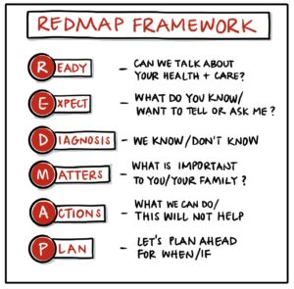 | Future care planning discussions may include:  - What matters for this person if their health changes.  - Plans for hospital care - admission, outpatient visits, tests and treatments. Depends on the person’s health problems, situation, and goals of care.  - Treatments/medicines that help, could stop, will not work or have a poor outcome.  - Cardiopulmonary resuscitation (if relevant).  - Choosing proxy decision-makers (Power of Attorney)  - Care or support they’d like; anything they do not want.  - Help and support for family/friends/carers.
Tips on starting conversations about changes in health, and care planning
“I am glad you feel better and I hope you will stay well, but I am worried that you could get ill again…”
“Can we talk about how we manage when we are not sure what will happen and when?”
“If you got less well, what would be important for you?” “What would (name) say about this? Why is that?”
“Some people find it helps to talk about whether to go to hospital or not if they get ill….”
www.spict.org.uk 2025

